# Name :- Yash Gupta Uid :- 20BCS5009

# Course :- CSE Section :- 704-A

# Subject :- Programming in Python Subject Code :- 20CSP-259

1. Python Program to check whether a given number is a palindrome.

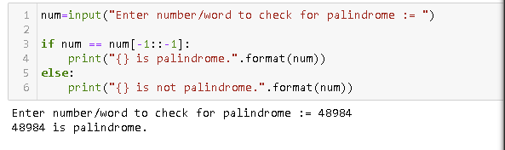

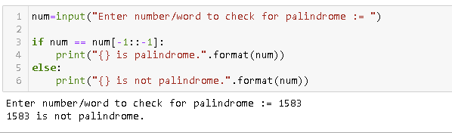

1. Python Program to check Whether entered number is Armstrong or Not?

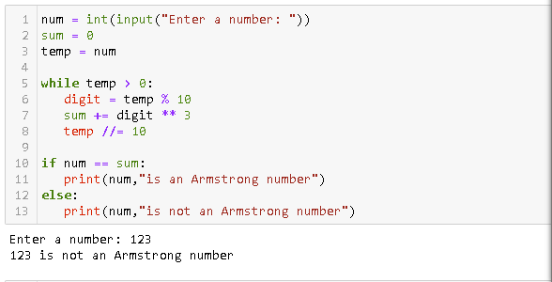

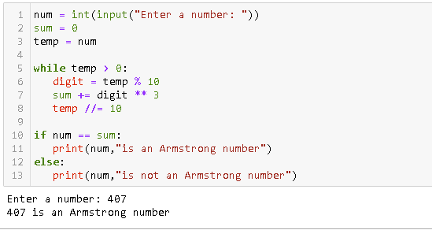

1. Python Program to Take three numbers from the user and print the greatest number

